**DBMS PACKAGE -20XW38**

**TRAIN TICKET RESERVATION SYSTEM**

TEAM MEMBERS:

1.ABISHEK A-20PW01

2.SAI DINESH B-20PW30

ABSTRACT:

The railway reservation system facilitates the passengers to enquire about the trains available on the basis of source and destination, booking and cancellation of tickets, enquire about the status of the booked ticket, etc. The aim of case study is to design and develop a database maintaining the records of different trains, train status, and passengers. The record of train includes its number, name, source, destination, and days on which it is available.

Passengers can book their tickets for the train in which seats are available. For this, passenger has to provide the desired train number and the date for which ticket is to be booked. Before booking a ticket for a passenger, the validity of train number and booking date is checked. Once the train number and booking date are validated, it is checked whether the seat is available. If yes, the ticket is booked with confirm status and corresponding ticket ID is generated which is stored along with other details of the passenger. The ticket once booked can be cancelled at any time. For this, the passenger has to provide the ticket ID (the unique key). The ticket ID is searched and the corresponding record is deleted. With this, the first ticket with waiting status also gets confirmed.

**ER DIAGRAM :**

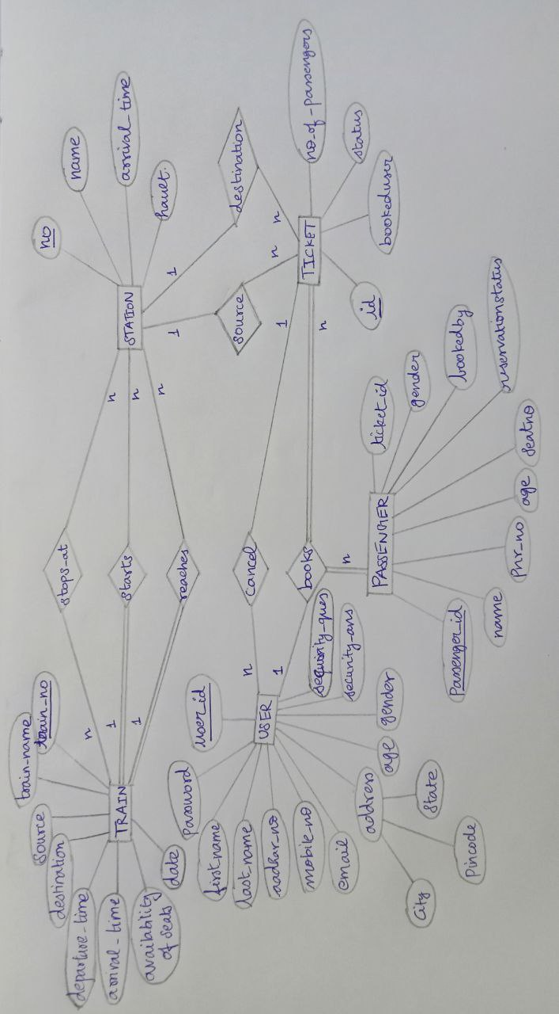

**FINAL NORMALIZED TABLES:**

